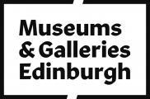

Accessibility Guide for Lauriston Castle
lauristoncastle@edinburgh.gov.uk, +44 (0) 131 336 2060, https://www.edinburghmuseums.org.uk/venue/lauriston-castle
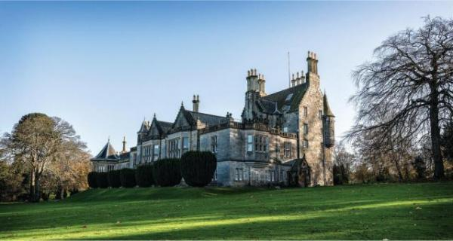

Welcome
With its calm, tranquil atmosphere, and stunning views across the Firth of Forth, Lauriston is the perfect place to escape from the bustle of the city centre.
Enjoy a woodland walk, a visit to our award-winning Japanese garden, or step back in time and experience what life was like in an Edinburgh middle-class home at the beginning of the 20th century.

At a Glance

Level Access
- There is level access from the main entrance to:
  - Cafe
  - Outdoor accessible toilets
  - Castle Gardens

Access with steps
- There are steps from the Castle main entrance to:
  - First Floor
  - Mezzanine Floor (Library)

Visual
- Some parts of the venue have low lighting.
- We have display information in large print and other.

General
- We have a concessionary rate for disabled visitors.
- We have a complimentary ticket policy for personal assistants.
- There is at least 1 public toilet for disabled visitors.

Getting here
2 Cramond Road South
Edinburgh
EH4 6AD

Travel by public transport
- You can get to Lauriston Castle by bus and train.
- Barnton Park (for buses 47 and 47B) located just outside the entrance to Lauriston Castle. Davidson's Mains (for bus 21) or Silverknowes Terminus (16, 27, 29 and 37), both are around 10 minutes walk away from Lauriston Castle The bus stop is 0.2 miles / 0.3 km from Lauriston Castle.
- The nearest train station is Edinburgh Haymarket. The train station is 3.4 miles / 5.5 km from Lauriston Castle.
- Waverley Station in the city centre may be more convenient for picking up bus routes out in the direction of Lauriston Castle. The 29 and 37 pass along Princes Street near to Waverley Station. A taxi ride takes about 25 minutes.

Travel by taxi
- You can get a taxi with City Cabs by calling 0131 228 1211. The taxi company has a wheelchair accessible vehicle.

Parking
- There is parking near the venue. There are accessible parking spaces. Parking is free.
- There is a drop-off point at the main entrance. The drop-off point has a dropped kerb.
- From the car park to the entrance, there is level access. The distance between the parking and the castle is about 5 minutes walking.
There is accessible parking at the entrance of the castle.
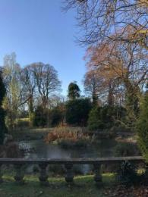
View from the path
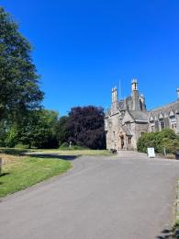
The road to the castle entrance and accessible parking.

Arrival

Main entrance
- The castle door is 770mm wide.
- The castle main entrance has 4 steps.
- The castle main door is side hung and manual.
- The other entrance door is 790.00mm wide.
- When you approach the path, the accessible entrance is one the right of the café, through a courtyard
- The accessible entrance leads you to the old kitchen and staff offices. Unfortunately, due to the historic nature of the castle, the visitor route is not accessible to wheelchair users. Nevertheless, there is a power point presentation with photographs of the castle that the staff would be happy to show you.
The castle can be visited by guided tour only and must be arranged in advance. For a group, if you have any special requirement, please contact us.
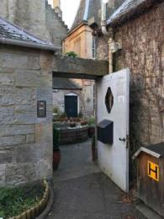
Courtyard entrance
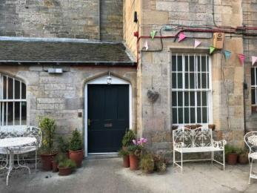
Accessible castle entrance from the courtyard
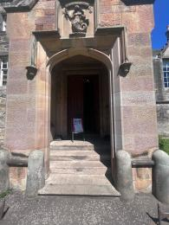
The steps to the main entrance

Getting around inside

Visual Impairment - General Information
- Some parts of the venue have low lighting.
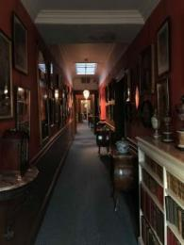
Low lit corridor on the visitor route

Things to See and Do
- We have a concessionary rate for disabled visitors.
- We have a complimentary ticket policy for personal assistants.
- We have display information in: large print .
- Large print information can be printed if you requested before your visit by email

First Floor
- From the main entrance to this area, there are 14 steps. There is no lift and no ramp.
- Some display information is low, for wheelchair users. There are seats.
- Once visitors have reached the first floor via the main entrance, all rooms are on the same level except the library and the kitchen (on the lower ground floor and mezzanine floor). All doors are approximately the same size (around 108 cm)
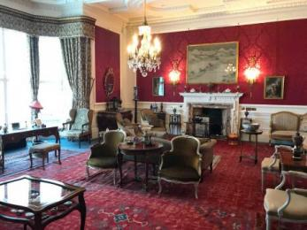
Drawing Room
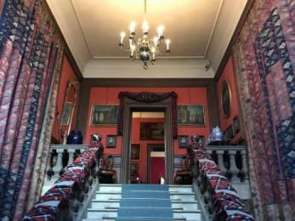
Grand staircase from main entrance to first floor
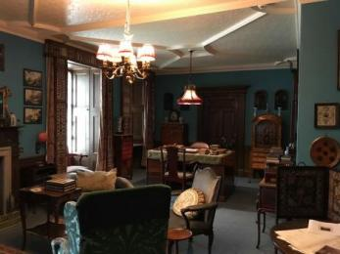
The Study

Mezzanine Floor (Library)
- From the main entrance to this area, there are 7 steps. There is no lift and no ramp.
- There are seats.
- The library is low light and only accessible via a small staircase.
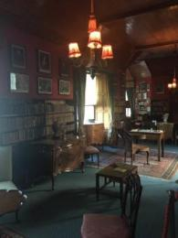
The Library

Public toilet

Outdoor accessible toilets
- There is a public toilet for disabled visitors.
- From the main entrance to the public toilet, there is level access. There is a permanent ramp.
- The toilet door is 890mm wide.
- The direction of transfer onto the toilet is to the left.
- The toilet seat is 500mm high. The toilets have handrails.
- There are also baby changing facilities available and a disabled assistance button.
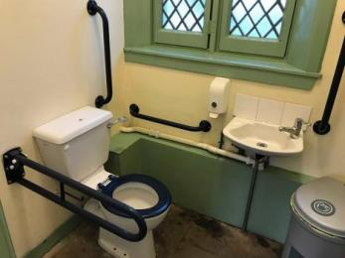
Accessible toilet
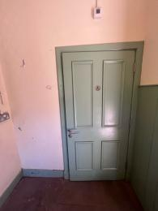
Door to the accessible toilet
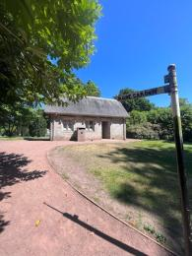
Path to the toilet block with accessible toilet

Place to eat and drink

Mimi's Little Bakehouse
- From the main entrance to the dining area, there is level access. The door is 900mm wide.
- To get to a table, there are no steps.
- There is no background music.
- For information about Mimi's Little Bakehouse menu, please visit the website: https://mimisbakehouse.com/locations/lauriston-castle/

Getting around outside

Castle Gardens
- From the main entrance to the gardens, there is level access.

Picnic Area

Castle Grounds
- You can bring your own food to the picnic area.
- The grounds are open on a daily basis for dog walkers and the general public. Depending on the weather, please feel free to bring picnic blankets and sit on the grass.

Customer care support

Customer care support
- If you are bringing a group, please contact the castle staff in advance and ask about any special requirements you may have.
- We have other services for people with accessibility requirements.
- Opposed to a guided tour, there is also a virtual tour using a powerpoint possible for visitors.

Guide last updated: 23 April 2024

