# *CLASSICAL EDINBURGH* PHOTOGRAPHY COMPETITION

## *#CLASSICAL EDINBURGH*

## MUSEUMS & GALLERIES EDINBURGH and JESSOPS

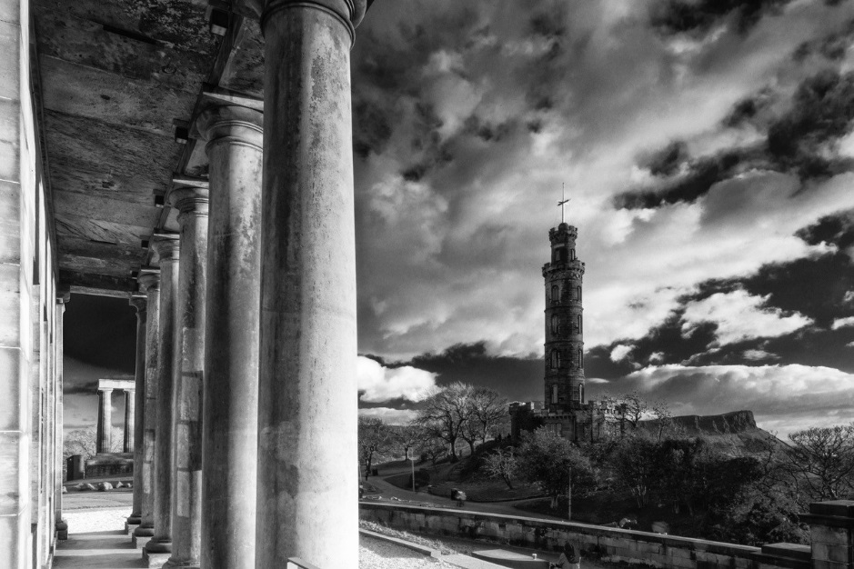

Photography: Colin McLean

This is an opportunity for local Edinburgh photographers and students studying photography in Edinburgh to be part of our forthcoming exhibition *Classical Edinburgh,* to be held at the City Art Centre in Edinburgh during the winter of 2019/20.

**Edinburgh City Art Centre** is pleased to announce that November 2019 will see the opening of a new exhibition titled *Classical Edinburgh*. The exhibition will be a celebration of Edinburgh’s neo-classical architecture, as seen through the eyes of two architectural photographers, working half a cen­tury apart.

Edwin Smith (1912-71) was described by John Betjeman as “a genius at photography” and his work had illustrated many books on rural life and lat­terly, concentrating on architecture. Edinburgh Univer­sity Press commissioned Smith to provide the photo­graphs for “The Making of Classical Edinburgh” by A J Youngson. The book, first published in 1966 and still in print today, quickly established its position as the authoritative work on the New Town, and helped stim­ulate a new interest in its Georgian architecture and the need for its conservation.

Colin McLean is an ar­chitectural photographer who has spent the last two years re-interpreting Smith’s evocative black and white images of the city in the 1950s and ‘60s. This will be a homage to Smith’s photography, a celebration of the City’s neo-classical architecture, and a reflection on the changes over the last 50 years. In September, Edinburgh University Press is launching a new version of “The Making of Classical Edinburgh”, with a new preface by Colin McLean and a selection of his new photographs.

We are inviting photographers to be part of this exhibition by entering photographs capturing your vision of Classical Edinburgh. The winning entries will have their photographs on display in the City Art Centre from 9 November 2019 to 8 March 2020. To assist entrants, we are listing some city areas/buildings that are included in this competition.

## Locations

|  |  |
| --- | --- |
| The First New Town | Princes Street, George Street, Queen Street, Charlotte Square, St Andrew Square, Rose Street, etc |
| The Northern, or Second New Town | Dundas street, Great King Street, Northumberland street, Shandwick Place, Picardy Place, etc |
| Eastern, or Third New Town | Calton Hill, Regent Terrace, Carlton Terrace, etc |
| All places that were photographed by Smith for the original book. | George Square, Stockbridge, Old College |

## *PLEASE NOTE WE WILL NOT ACCEPT PHOTOS OUTWITH THESE LOCATIONS.*

## Categories

We have 4 Categories that you can enter your work into.

1. After Dark: Views of the city once the daylight has gone.
2. Seasons: The heart of Edinburgh throughout the year.
3. Working Life: The daily hustle and bustle of city life.
4. Architectural Gems: Unusual glimpses or facets of buildings, interiors, streets, panoramas.

## *PLEASE NOTE WE WILL NOT ACCEPT PHOTOS WITHOUT A CATEGORY.*

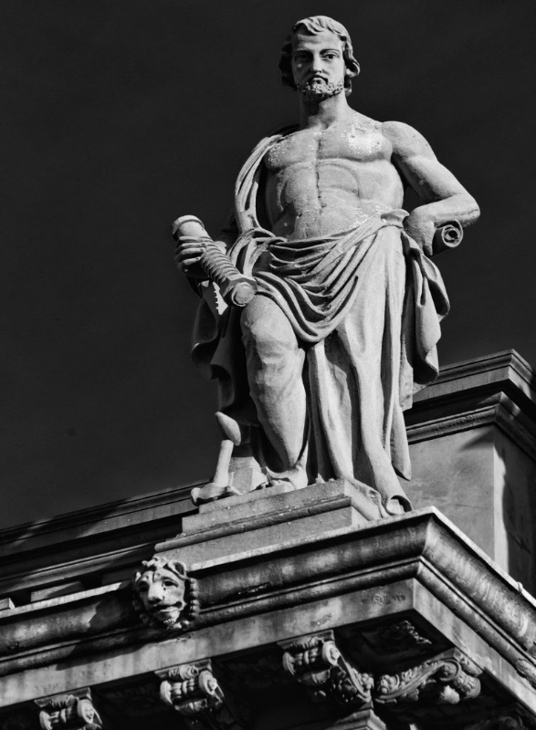

Photography: Colin McLean

## Winners

Your work will be displayed in the City Art Centre alongside the exhibition *Classical Edinburgh.*

You will be credited on the Acknowledgements Panel within the exhibition

You and 4 guests will be invited to the Private View of the exhibition on Thursday 14th November.

Your work will be promoted across all City of Edinburgh Council media channels and on our website.

A separate press call will be organised profiling the work of all the winning entries.

We are delighted to be collaborating with Jessops. Jessops will produce the winning works.

## Competition Guidelines

1. To enter you must like and follow our City Art Centre Facebook page. Post your entry on our City Art Centre Facebook page. Only one entry per category will be accepted. On your Facebook post state the title of your photograph, location taken and the category you are entering, also using the following hashtag.

**#ClassicalEdinburgh**

If you have your own photography page we will share that. Please include link in post.

2. The judging panel will consist of a panel of curators and experts in the photography field.

3. The winners will submit their photograph as a high resolution digital file and we will cover the enlargement production costs. Preference will be given to portrait formats but we will also accept landscape photographs. We reserve the right to crop images to fit the exhibition display. Any crops will be agreed with the photographer.

4. No photographs taken on a mobile phone can be accepted. This is because we will be enlarging the images substantially in the exhibition. We will need winning files submitted as tiff files at 300 dpi.

5. By submitting a photograph to ***Capture Classical Edinburgh*** photo competition, you give permission to City of Edinburgh Council to re-use the image free of charge in promotional material relating to this exhibition, on our social media and alongside this exhibition. Images will be appropriately credited.

6. To facilitate the highest quality printing of winning photographs the City Art Centre will contact winning photographers to obtain original image files. The size of printed photographs may depend on the resolution of the original photograph. This will have no impact a photographs chances of winning.

7. The Competition will run from 17July 2019 to 15 September 2019. Judging will take place in early October.

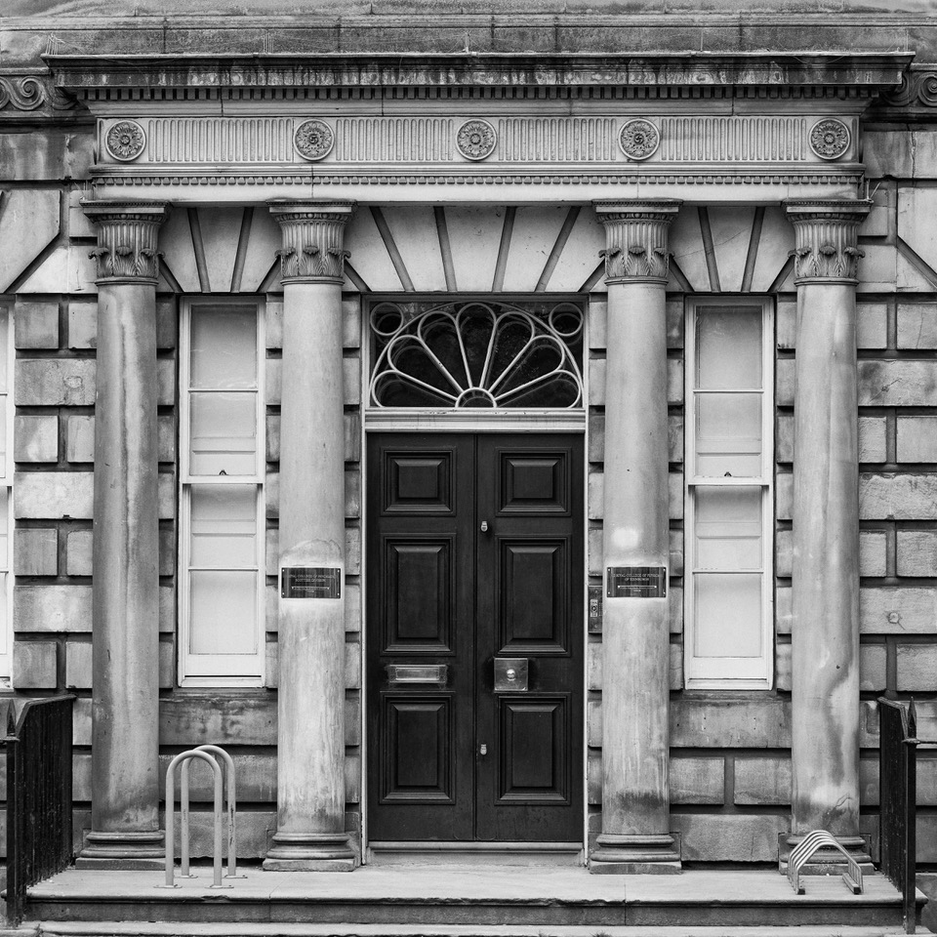

**Photography: Colin McLean**